#include <stdio.h>

int linearS(int arr[], int n, int pass) {

for(int i = 0; i < n; i++) {

if(arr[i] == pass) {

return i;

}

}

return -1;

}

int main() {

int arr[100], n, pass, result;

printf(" number of elements are: ");

scanf("%d", &n);

printf("Enter %d elements:\n", n);

for(int i = 0; i < n; i++) {

scanf("%d", &arr[i]);

}

printf(" the element to search: ");

scanf("%d", &pass);

result = linearS(arr, n, pass);

if(result != -1)

printf("Element found at index %d.\n", result);

else

printf("Element not found.\n");

return 0;

}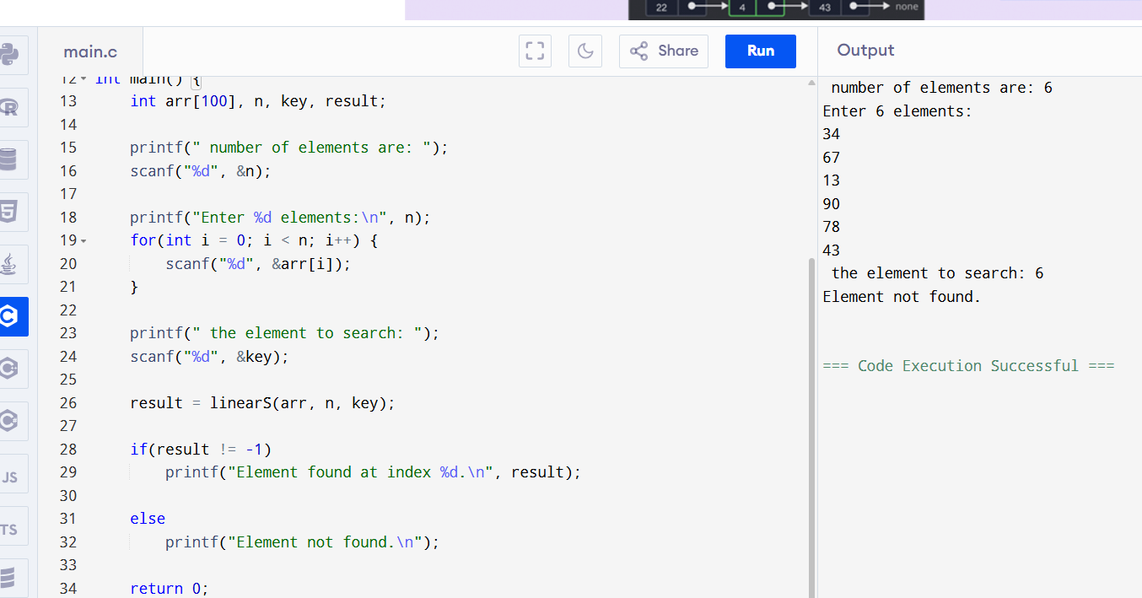

Code -2

#include <stdio.h>

int binaryS(int arr[], int n, int element) {

int low = 0, high = n - 1;

while (low <= high) {

int mid = low + (high - low) / 2;

if (arr[mid] ==element )

return mid;

else if (arr[mid] < element)

low = mid + 1;

else

high = mid - 1;

}

return -1;

}

int main() {

int n,element ;

printf("the number of elements in the sorted array: ");

scanf("%d", &n);

int arr[n];

printf("Enter %d sorted elements (in ascending order):\n", n);

for (int i = 0; i < n; i++) {

scanf("%d", &arr[i]);

}

printf("the element to search: ");

scanf("%d", &element);

int result = binaryS(arr, n, element);

if (result != -1)

printf("Element is found at index %d\n", result);

else

printf("Element not found in the array\n");

return 0;

}

